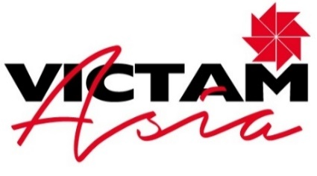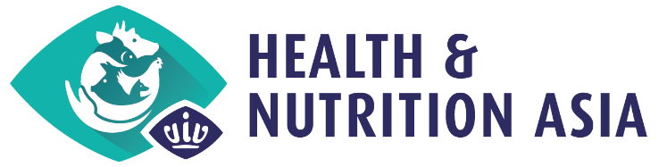

SHOW PREVIEW – PRESS RELEASE
[August 23, 2022 | Bangkok, Thailand]

join in 2 weeks the Total Animal Feed and Health event in Bangkok, thailand
Time to meet the industry face-to-face for three days of business talks in Asia!

VICTAM Asia in co-location with Health & Nutrition Asia are ready to kick-off from September 7-9, 2022, at the IMPACT Halls 9 and 10, in Bangkok, Thailand.

Innovations in Animal Health and Nutrition
Everything is set for an unmissable 3-day B2B event full of networking activities, business opportunities and a rich content program. More than 400 exhibitors will be showcasing their latest solution in animal health, feed ingredients and additives, genetics, and feed technology.

This unique event will introduce you to many innovations developed in the last years and now finally gathered under one roof, after a long pause. New feed probiotics, infrared spectrometers, new diet elements to improve animal’s absorption of energy from fats and oils, innovative pig genetic programs, heavy cleaning solutions for drinking systems, milk replacers and sesame meals, and many other new products to help you optimize your animals’ health and feed conversion, will be showcased onsite where experts are ready to guide you through the best solutions for your own business development.

VIV has the largest worldwide network in animal health and nutrition and is best-connected in Asia.
VICTAM is the world’s largest feed & grain event. The co-location of their respective shows offers a
unique platform to dive into the most relevant player in the field of feed, nutrition, pharma, genetics, health
and veterinary technology, health monitoring and management.

The full exhibitor list is available on the official show websites www.vivhealthandnutrition.nl and www.victamasia.com.

Tailor-made content programs for vets, nutritionists, farmers, and more.
Next to the exhibition halls, a very professional line-up of speakers presented by the show organizers and their industry partners, will disclose important information about hot topics in the sector.

The Asian Food and Feed Industry Association (AFFIA) organizes a 4 hour program, while the Asian Federation of Biotechnology (AFOB) will talk about the “Feed additives alternative to antimicrobial growth promoters”. The Federation of Asian Veterinary Associations (FAVA) will present the “FAVA Strategy to tackle AMR 2021-2025” and the Thai Feed Mill Association (TFMA) will highlight the importance of the “Target 2040: Net Zero Emission”. Perendale Publishers will be back with their recurring and successful programs, such as the “Aquatic Asia” conference and “Build my Feed Mill”. The conference program is available on www.vivhealthandnutrition.nl/visit/conference-program.

Among its speakers, the show will welcome Dr. Penjit Srinophakun, President of the Thai Society for Biotechnology and Vice President of AFOB, Dr. Quaza Nizamuddin Bin Hassan Nizam, FAVA President, Andriy Revva, Regional business manager of Alfa Laval Copenhagen, and many more.

At the networking reception, FAVA and VIV will also announce the winners of the Asian Animal Health Award 2022, in appreciation of the extraordinary work done by outstanding experts in the veterinary field.

Other conference and show key partners are the Department of Livestock Development, the Animal Health Products Association, the Northeastern Pig Producer's Association, the Panyapiwat Institute of Management, the Thai Association of Veterinary Laboratory Diagnosticians (TAVLD), the Thai Poultry Veterinary Association (TPVA), the Thai Ruminants Veterinary Association, the Thai Swine Veterinary Association, the Animal Husbandry Association of Thailand (AHAT), the Swine Raisers Association of Thailand and the World Veterinary Poultry Association, Malaysia.

Many reasons to join VICTAM Asia and Health & Nutrition Asia: stay up-to-date with the current industry trends, join the largest network in Asia in feed and animal health, get free access to this unique in-person event for the animal industry in Asia in 2022 and find out all the main products & solutions developed for Asia by global players.

Thailand relaxed entry measures for travelers
Visitors coming to Thailand simply need to exhibit their vaccination certificate or, if unvaccinated or not fully vaccinated, a proof of a negative PCR test within 72 hours of arrival.
A free shuttle bus daily between BTS Mochit to IMPACT will be available from 7-9 September. The schedule will be published on the website and social media from September 1.

Registration for professional buyers and visitors is now open on the official websites www.victamasia.com and www.vivhealthandnutrition.nl.
See you in Bangkok, Thailand from September 7-9, 2022 at VICTAM Asia and Health & Nutrition Asia, by VICTAM and VIV.

------------------------------------------------------ End of Press Release----------------------------------------------

Press contacts:
- Ms. Saengtip Techapatiphandee, saengtip@vnuexhibitionsap.com, Marketing Manager VNU Asia Pacific
- Ms. Elena Geremia, elena@vnueurope.com, Senior Marcom Manager VIV worldwide
- Ms Catelijne de Gooijer, catelijnedegooijer@victam.com, Marketing Manager, VICTAM

